**Assignment 7**

**Task 1. Create a new Date Table using DAX.**

In the data view, after selecting New Table, enter formulas for Date, Year,MonthNum,MonthFull, MonthAbbr, QuarterNum,QuarterFull, QuarterAbbr as follows

Date = CALENDAR(MIN(Invoices[InvoiceDate]),MAX(Invoices[InvoiceDate]))

Year = YEAR('Date'[Date])

MonthNum = MONTH('Date'[Date])

MonthFull = FORMAT('Date'[Date],"MMMM")

MonthAbbr = FORMAT('Date'[Date],"MMM")

QuarterNum = QUARTER('Date'[Date])

QuarterFull = FORMAT('Date'[Date], "\Quarter Q")

QuarterAbbr = FORMAT('Date'[Date],"\QQ")

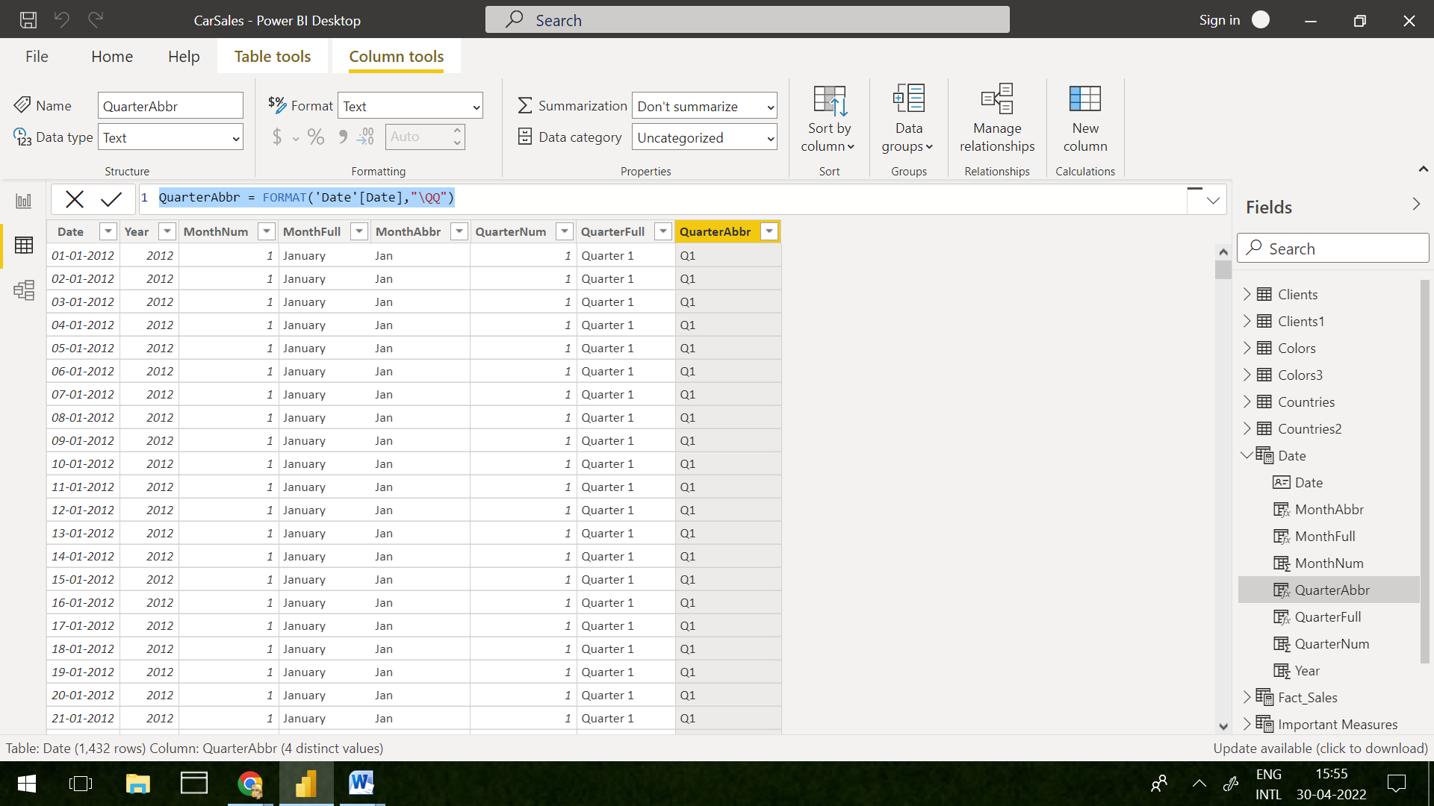

**Task 2.Create a new measure to find the quarterly sales.**

**DAX formula to measure Quarterly sales**

QuarterlySales = CALCULATE(SUM(InvoiceLines[SalePrice]),DATESQTD('Date'[Date]))

To represent Quarterly Sales measure, we select bar chart visualisation and then under axis we drag and drop QuarterlyFull field from Date table.Also, under values we drop the measure created to achieve the desired output.

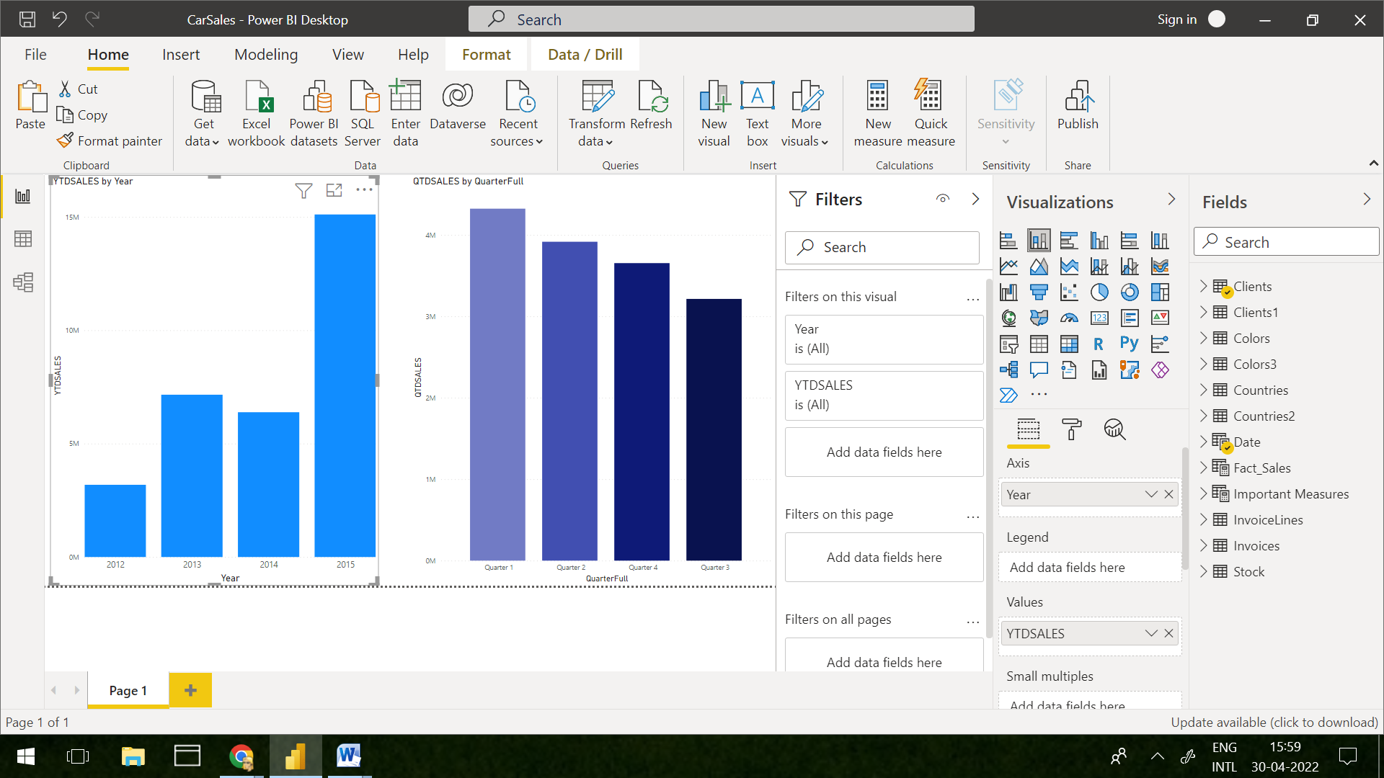

**Task 3. Create a new measure to find the yearly sales.**

2012YearlySales = CALCULATE(SUM(Fact_Sales[SalePrice]),FILTER('Date','Date'[Year]=2012))

2013YearlySales = CALCULATE(SUM(Fact_Sales[SalePrice]),FILTER('Date','Date'[Year]=2013))

2014YearlySales = CALCULATE(SUM(Fact_Sales[SalePrice]),FILTER('Date','Date'[Year]=2014))

2015YearlySales = CALCULATE(SUM(Fact_Sales[SalePrice]),FILTER('Date','Date'[Year]=2015))

To represent Yearly Sales measure, we need to create separate measures year-wise and then select bar chart visualisation followed by dragging 2012YearlySales, 2013YearlySales, 2014YearlySales, 2015YearlySales measures under Value section and dropping Year field from Date table to Axis section.

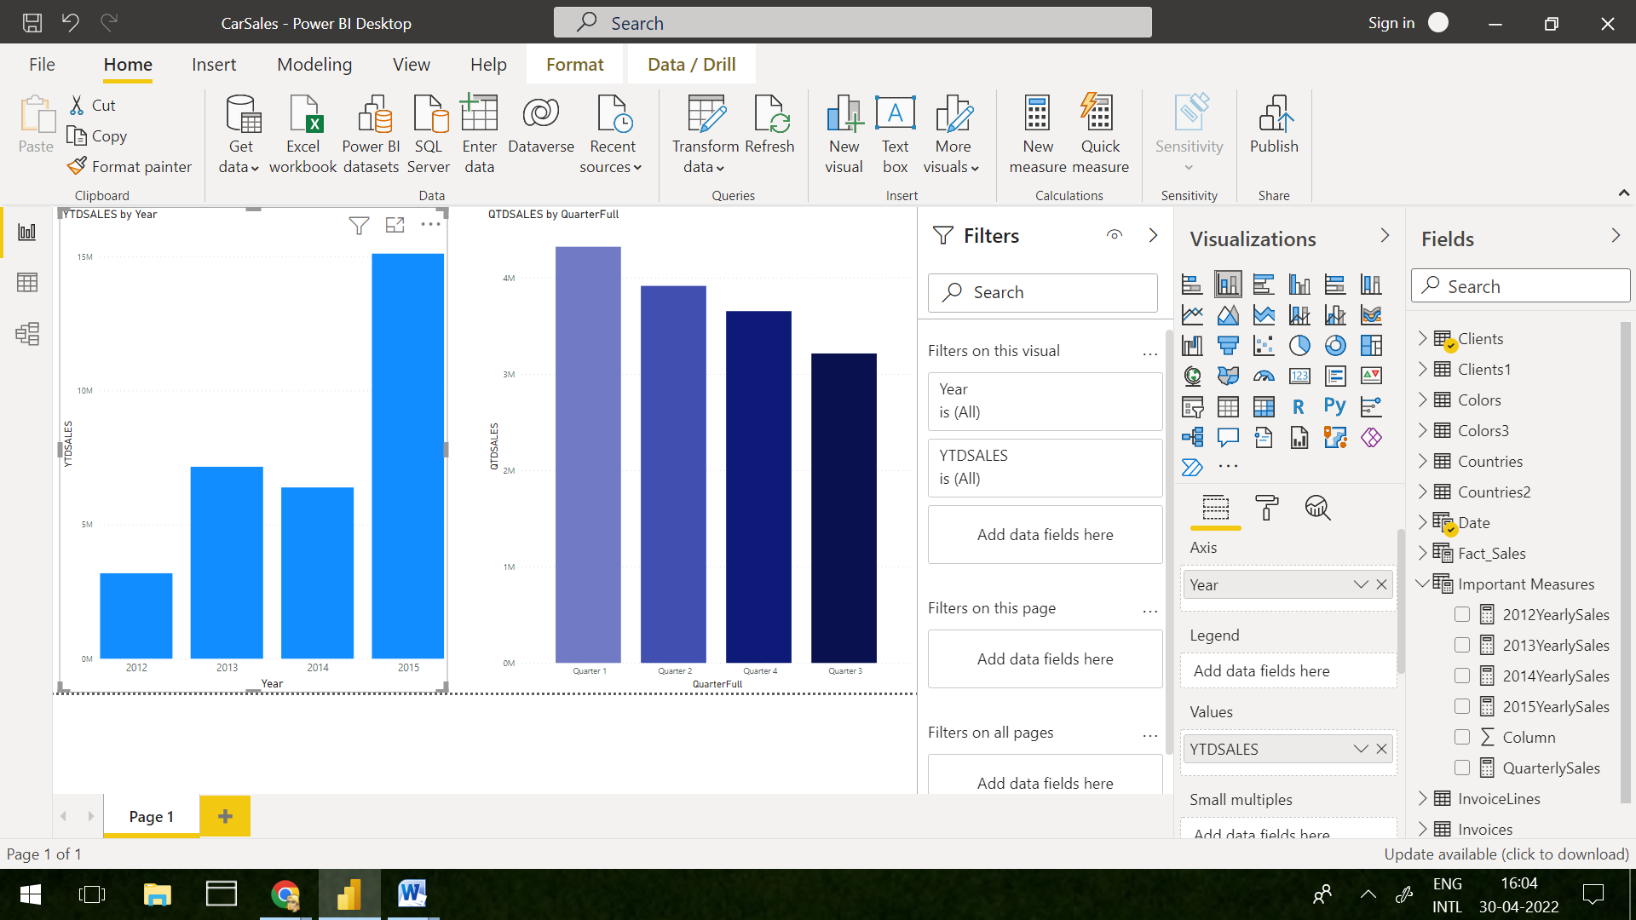

**Task 4. Create a new table called Fact_Sales containing the data as follows**

We can create new Fact_Sales table by first selecting New Table under Tabletools and then using below DAX formula to get desired output

Fact_Sales = SELECTCOLUMNS(InvoiceLines,"SalePrice",InvoiceLines[SalePrice],"CostPrice",RELATED(Stock[CostPrice]),"LaborCost",RELATED(Stock[LaborCost]),"SpareParts", RELATED(Stock[SpareParts]),"InvoiceDate",RELATED(Invoices[InvoiceDate]))

TotalCost = Fact_Sales[CostPrice]-(Fact_Sales[LaborCost] + Fact_Sales[SpareParts])

